YuYu Chen

*Computer Engineering Department, College of Engineering*

*San Jose State University, San Jose, CA 95192*

*E-mail: yuyu.chen@sjsu.edu*

[1]

Embedded Wireless Architecture Implementation with LPCXpresso1769 module

*Abstract*— This lab report’s objective is to document the design and implementation of several wireless communication between two embedded systems modules. The first part of the report will detail landline communication and wireless communication between two embedded systems using a standard RF module. The second part of the report will detail the use of a state-of-the-art LoRa module communication between two embedded system modules.

# INTRODUCTION

The first objective for two embedded system modules (node $N_{i}$ and node $N_{j}$) to communicate with each other is to establish synchronization between the two nodes. The technique used to establish synchronization is the Linear Invariant Synchronization Algorithm (L.I.S.A). L.I.S.A algorithm allows the user to recover the payload even when there are corrupted bits or timing error during synchronization. The payload is scrambled before transmission by node $N_{i}$ and descrambled by node $N_{j}$ when receiving the payload. The embedded system module used is LPC1769 microcontroller.

The report will begin with detailed descriptions of the methodology used, such as the objective and details. The next section will describe the implementation with the software. The last part of the report will be Testing and Verification, along with conclusion, reference, and appendix.

# Methodology

This section includes objectives of the lab, hardware design of the project in schematics, system setup in block diagrams, and layout of the prototyping board.

*A: Objectives*

The first objective of the lab was to establish synchronization between node $N_{i}$ and node $N_{j}$ using L.I.S.A algorithm. The next step was to write firmware drivers for the embedded system. Scrambling and descrambling algorithm is also used to reduce long sequences of “0”s and “1”s during wireless transmission.

1. Implement L.I.S.A algorithm in C to establish synchronization. Able to recover payload based on given confidence level.
2. Implement firmware drivers for LPC1769 to transmit and receive payload.
3. Implement Scrambling and descrambling algorithm.
4. Establish landline communication between node $N_{i}$ and node $N_{j}$.
5. Establish wireless communication between node $N_{i}$ and node $N_{j}$.

The second objective is to use a module with LoRa, which is a long-range modem that provides ultra-long-range spread spectrum communication and high interference immunity whilst minimizing current consumption.

1. Establish SPI interface embedded system and LoRa module
2. Establish handshaking between node $N_{i}$ and node $N_{j}$ using LoRa module.
3. Modify parameters (registers) for cognitive radio implementation

*B: Design*

This section shows the layout of the prototyping board, system setup in block diagrams, and design schematics in detail. To connect the hardware components onto the wire wrapping board, soldering and wire wrapping were needed to hold the components firmly onto the board.

Hardware Design:

Two embedded boards were designed per node. One board consists of the microcontroller and two RJ45 jacks. The other board consists of one 433MHz ASK RX and TX pair and three RJ45 jacks. A cat5 ethernet cable is used connect the two boards together or with another embedded board.



Figure 1: Embedded Node Communication

 Figure 1: Wire wrapping board layout with console

The RJ45 jack on the top-right of Figure 1 is used to connect to the RF board, providing $V_{CC}$ (from power supply), ground, TX (P0.2), and RX (P0.3). The other RJ45 jack on the bottom-right of Figure 1 is used to connect to node $N_{j}$, connecting ground, TX (P0.2), and RX (P0.3) for inter-process communication.

Figure 2: CPU module schematic

The pins chosen for TX and RX are J6-21 and J6-22, respectively. The pin assignments are shown in Table 1.

|  |  |  |
| --- | --- | --- |
| Pin Number | Description | Note |
| J6-21 | P0.2,  Tx, Output | GPIO  Transmitter |
| J6-22 | P0.3,  Rx, Input | GPIO  Receiver |
| J6-2 | Power |  |
| J6-1 | Ground |  |

Table 1: Pin Assignments for Embedded board

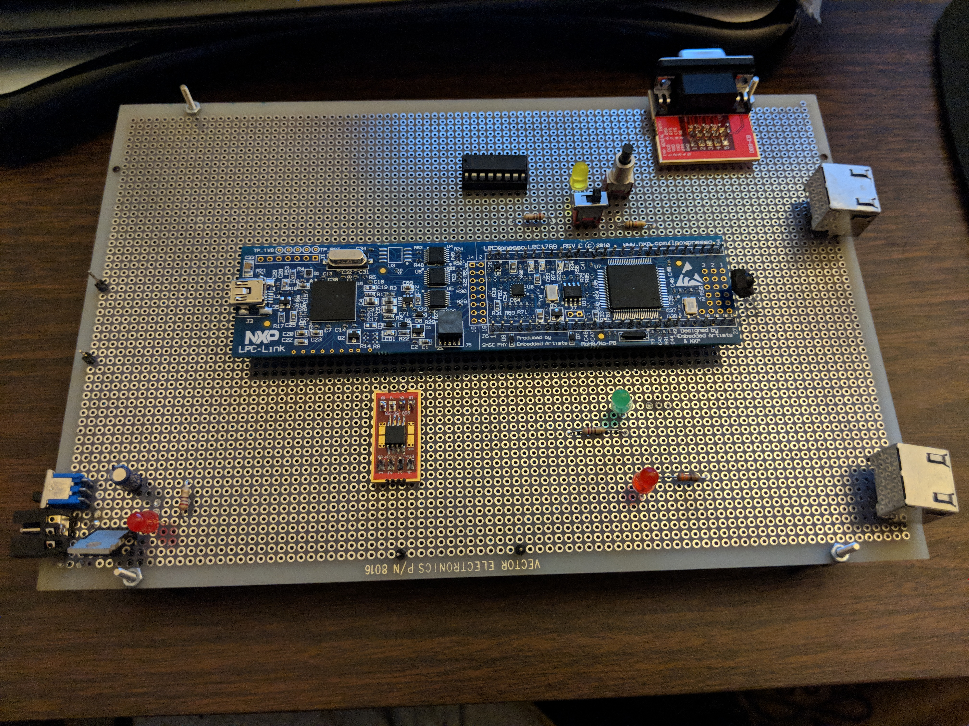

Figure 3: Layout of embedded board

The RF board is powered by 5V from the embedded board from one of the pins of the RJ45 jack. The switch on the RF board allows the user to only power one RF module at a time to reduce noise interference. The TX from the RJ45 jack goes to the Data port of the TX module, while the RX from the RJ45 jack goes to the Data port on the RX module. All modules on the device are connected to common ground. LEDs are added on to the RF board to let the user know which module is powered on when toggling the switch. The other LED is connected to the Data port of the RX module to visualize data being received.



Figure 4: RF board schematic

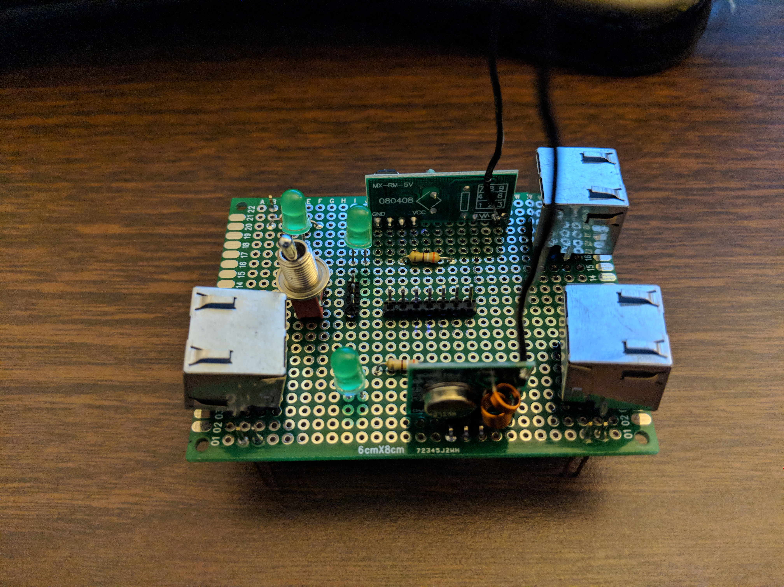

Figure 5: Layout of RF board

The SX1276 module is a transceiver that features LoRa. LoRa is a proprietary modulation technique by Semtech which can achieve a sensitivity of over -148dBm using a low-cost crystal. The module also allows the user to user FSK/OOK modulation. Some applications using LoRa are automated meter reading, home & building automation, wireless alarm and security system, industrial monitoring & control, and long-range irrigation systems.

|  |  |  |  |
| --- | --- | --- | --- |
| LPC1769 Pin Number | SX1276 Pin Number | LPC1769  Description | SX1276 Description |
| J2-7 | P.1 | SCK1 | RFL_LF |
| J6-2 | P.2 | VIO3V3 | VR_ANA |
| J2-5 | P.3 | MOSI1 | VBAT1 |
| J6-1 | P.4 | GND | VR_DIG |
| J2-8 | P.7 | SSEL1 | NRESET |
| J2-6 | P.8 | MISO1 | DIO0 |
| J6-21 | P.10 | GPIO (P0.2) | DIO2 |
| J6-2 | P.22 | VIO3V3 | RFO_HF |
| J6-1 | P.24 | GND | VBAT2 |
| J6-1 | P.32 | GND | GND |
| J6-2 | CON_P.34 | VIO3V3 | VDD_FEM |

Table 2: Pin Assignments for embedded board and SX1276 LoRa module

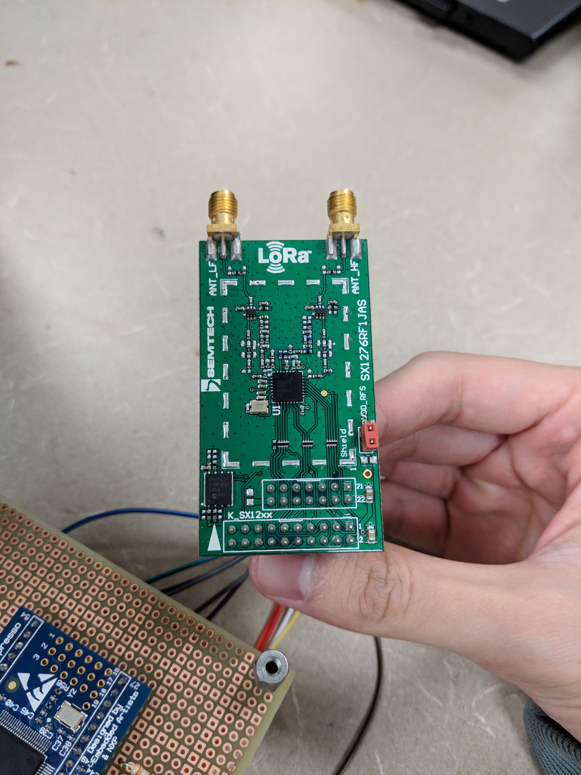

Figure 6: SX1276 LoRa module

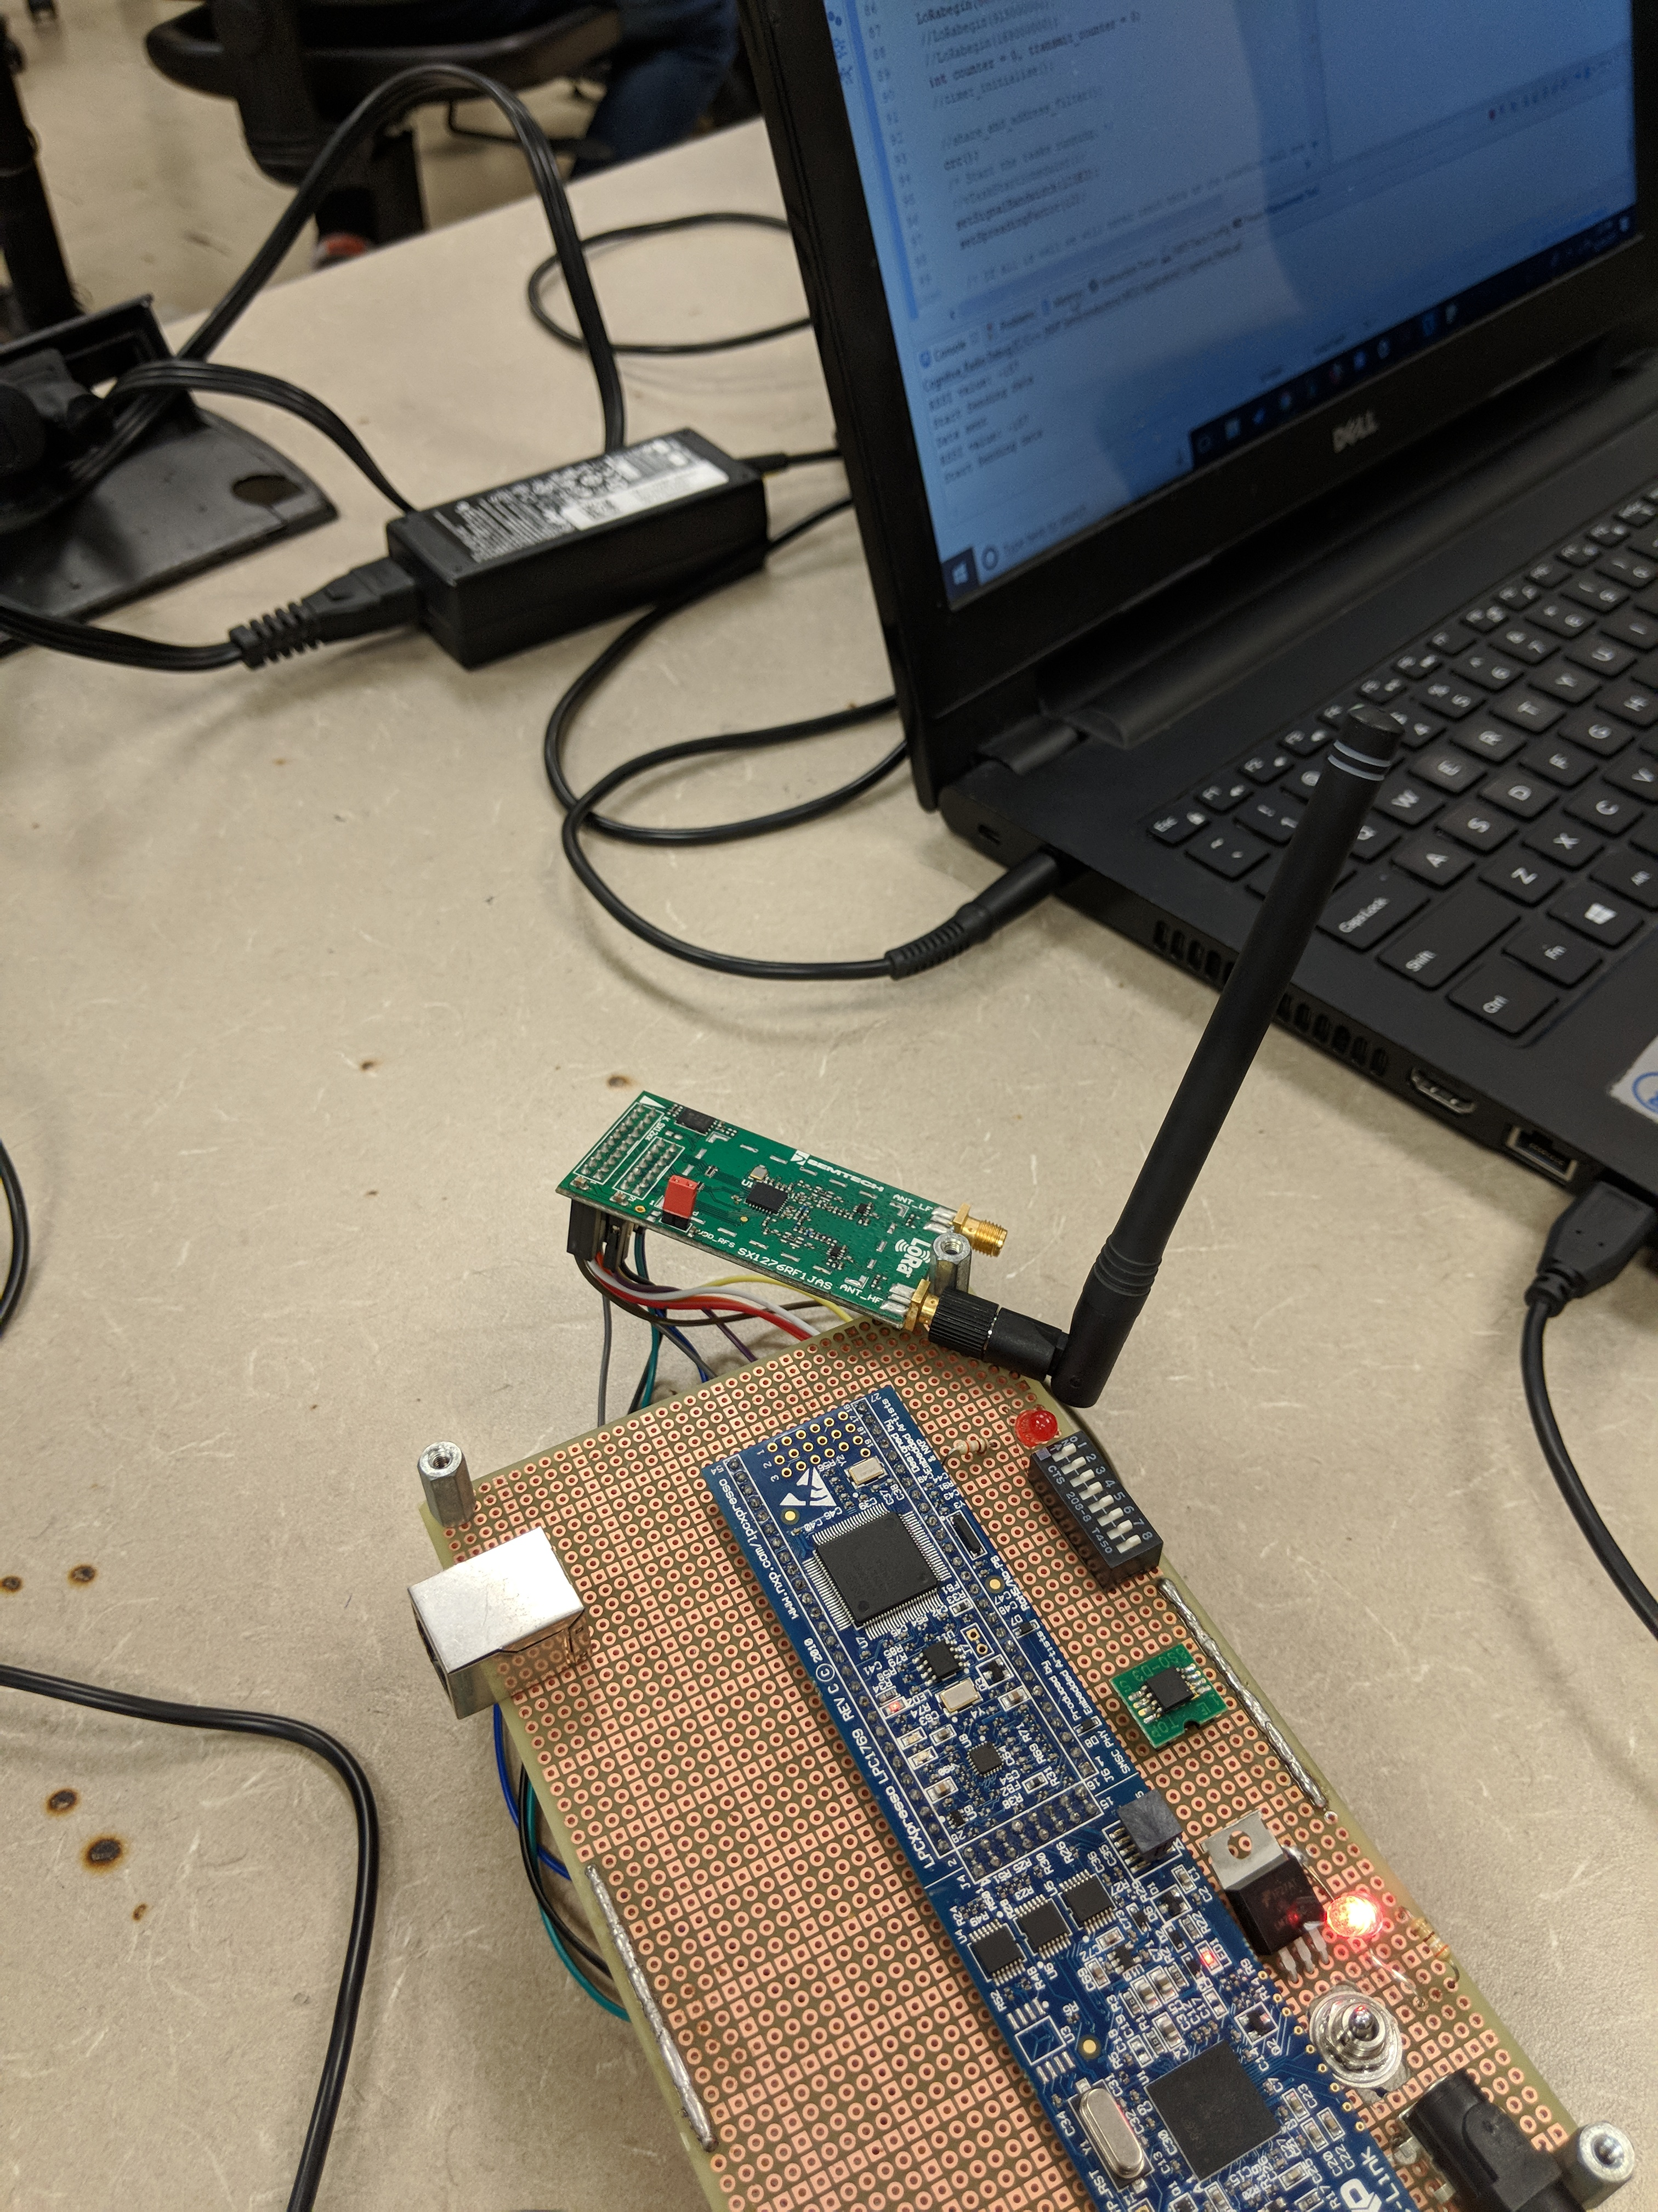

Figure 7: SX1276 LoRa module with Node

Software design:

L.I.S.A algorithm is used to sync and recover payload for two nodes communicating. L.I.S.A algorithm’s synchronization consists of alternating 4-bit patterns header of “1010” or 0xA and “0101” or 0x5. The other 4-bits consist of linear increment from 0x0 to 0xF. For example: 0xA0, 0xA1, 0xA2, …, 0xAF, 0x50, 0x51, …, 0x5F. Therefore, there will be a total of 32-bytes for the synchronization field. Using linear increment also allows the user to recover the starting point of payload. Alternating “0”s and “1”s are used to improve timing. Confidence level can be set by the user to match *n* number of bits for the data transmitted to be valid.

Implementing multiple drivers for the microcontroller is needed for both nodes to communicate. GPIO is used to transmit data by toggling the pin to output 3.3V or 0V depending on data being sent. GPIO is also used to receive incoming data by reading the pin. GPIO interrupt is also used to tell the receiver node to start sampling incoming data. A timer is also implemented to sample and transmit at a certain rate (highest rate achieved was 1Kbps). Therefore, both transmitter and receiver have to its timer set to the same rate to receive valid data.

Scrambler and descrambler is implemented in order to remove long sequences of “0”s and “1”s to improve timing and reduce jitter. The payload is scrambled before being transmitted and payload is descrambled on the receiver node. The user can input any order that is an odd number, such as 3, 5, 7, 9, etc. The higher the order the higher the polynomial, which increase its pseudo-randomness. Data is fed into delay units which delays it for one clock cycle. Depending on the order, outputs of the delay are XORed together and with the input to produce an output. At the receiver end, the descrambling is performed by subtracting the same sequence.



Figure 8: LISA algorithm field



Figure 9: Scrambler/Descrambler 5th Order Design

A list of registers is needed to be modified to implement cognitive radio. The follow lists of parameters are needed to be modified:

1. Frequency Band (FBW)
2. Working Frequency Range (WFR)
3. Bandwidth (BWD)
4. Coding Rate (CDR)
5. Spreading Factor (SPD)
6. Frequency Hopping Spread Spectrum (FHSS)
7. Error Correction and Detection Based Technique(CRC)
8. Address Based Communication (ADR)
9. Scrambling (Whitening) (SCR)
10. Beacon TX Mode (BCN)
11. TX Power (high power) (PWR)
12. Relative Signal Strength Indicator (RSSI)
13. Channel Filter (CNL)

Cognitive radio is a technique that allows the system to change its system parameters based on its communication channel to avoid interference and congestion. This technique will allow the system to “hop” to a frequency where it can achieve better or best performance.



Figure 10: LoRa Packet Structure

# Implementation

The implementation section interfaces the hardware module with firmware and software. The software implementation is done through MCUXpresso v10.0.2_411 IDE. The IDE allow the user to write C code to program their LPCXpresso1769 microcontroller module.

Two separate arrays with predefined data are created, one containing the L.I.S.A sync and the other is payload. After scrambling the payload, the two arrays are combined before being sent on the TX pin. A delay or a periodic timer can be used to send the data at a certain rate.

The receiver is implemented by first enabling GPIO interrupt on the receiver pin. The receiver pin will start sampling data at a certain rate based on the timer setting once it detects a rising or falling edge. After detecting an edge, the interrupt is disabled. Once sampled and storing in an array, the L.I.S.A algorithm reads the array to recover the payload. The L.I.S.A algorithm will iterate through the array until it matches the confidence level the user input at the beginning of the program. Once it matches the user’s confidence level, L.I.S.A algorithm will jump to the location of the starting payload. Before the payload is decode, the payload is first descrambled. The descrambled payload is then turned into ASCII character, so the user can read the payload.

Algorithm to TX and RX data for LISA & Descramble and Scramble:

1. Create sync field of 32 bytes consisting of 16 “0101xxxx” and 16 “1010xxx” patterns. Create payload array consisting of *n* amounts of bits that is divisible by 8.
2. TX: Scramble payload and combine with sync field. Transmit data using pin P0.2 with a periodic timer. After transmission, stop periodic timer.
3. RX: Enable GPIO interrupt and wait for rising or falling edge. After edge detection, disable interrupt and sample on RX pin P0.3 using a periodic timer. After data is received, stop the periodic timer.
4. Feed sampled data into L.I.S.A algorithm to locate starting position of payload.
5. Descramble payload and decode payload into human-readable format.



Figure 11: Flowchart for TX/RX LISA & Scramble Descramble algorithm

Pseudo Code:

Init_pins();

Init_timer();

Enable_timer_IRQ();

Enable_Eint3_IRQ();

Set_confidence_level();

Set_scramble_descramble_nth_order();

For TX:

Scramble();

Combine_sync_payload();

Start_timer();

Send_data();

// when done

Stop_timer();

Return success;

For RX:

Enable_interrupt();

If interrupt_triggered:

Disable_interrupt();

Start_timer();

Sample_rx();

// when done

Stop_timer();

Match_and_get_payload();

Descramble();

Decode_payload();

Return success;

The LoRa module is interfaced with a microcontroller using SPI interface. Details and register map are available in the datasheet to configure the settings. Initially, the frequency is set at 724MHz. Registers such as signal bandwidth, spreading factor, coding rate, frequency hopping period, and addressed based communication are set before transmission and reception. After transmitting or receiving, the node will hop to a new frequency for new transmission or reception based on a lookup table of predetermined frequencies.

Algorithm to TX and RX data for LoRa:

1. Configure registers to meet requirement of cognitive radio
2. Set to TX or RX mode
3. If RX, Check channel activity detection (CAD)
4. Transmit or receive data
5. If RX, Check Address Match
6. Hop to next channel
7. Repeat Step 2



Figure 12: Flowchart for LoRa RX/TX algorithm

Pseudo Code:

Lorabegin();

Set_settings();

If (tx)

Transmit();

If (rx)

If(activity detected)

Receive();

If(match)

Receive();

If(channel changed)

Set_new_freq();

# Testing and verification

L.I.S.A algorithm is tested by first implementing it on a laptop before porting it over to LPC1769. The program read a text file that is 1Kbytes with sync and payload. It would detect the sync field based on the given confidence level.

Drivers for LPC1769 are tested along the way of implementing. A logic analyzer is a useful tool for debugging embedded systems as the user can visualize waveform output, as well as timing information.

Scrambler and descrambler are tested by first implementing it on a laptop before porting it over to LPC1769. An array can be passed into the functions to scramble or descramble. The output of the scrambler will go into the descrambler and the descrambler should be the same as the input of the scrambler.

Landline testing is done first before doing wireless testing to test correct algorithm and bit rate. Different confidence level is tested as inputs to see how much data is corrupted or to see how fast data can be transmitted. Landline testing is done by connecting two embedded boards (nodes) together with a cat5 ethernet cable via RJ45 jacks.

Wireless testing is done after validating correct reception from the transmitter via landline testing. No data was received wirelessly between the two nodes when their antennas were both curled. The antennas had to be straightened out to receive data between the two nodes.

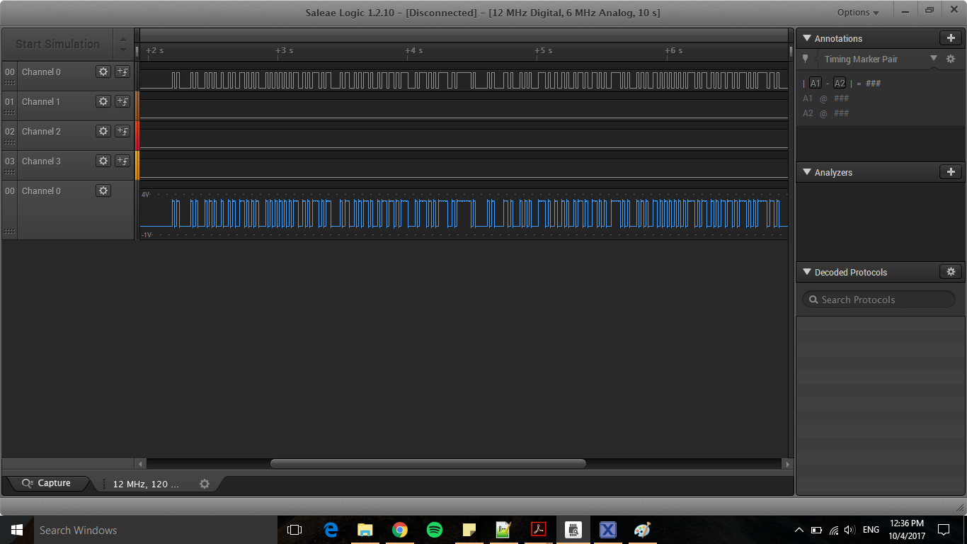

Figure 13: Logic analyzer waveform of data being transmitted on TX pin

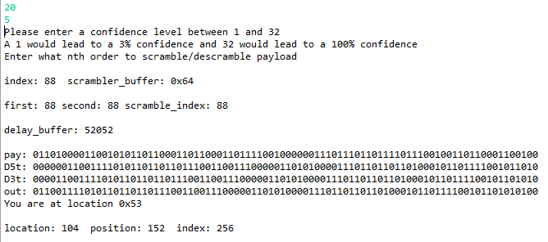

Figure 14: LISA with 5th Order Scramble on TX

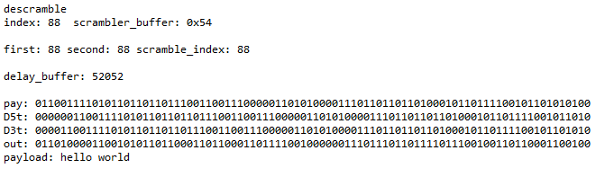

Figure 15: LISA with 5th Order Descramble on RX

As described in the implementation section, the cognitive radio RX/TX algorithm for LoRa is demonstrated in Figures 16-20. Node $N_{i}$ is used to send data initially. After successful reception on Node $N_{j}$, Node $N_{j}$, sends data back to Node $N_{i}$ and perform frequency hop. The procedure is the same for Node $N_{j}$ and continues until the user ends the program.

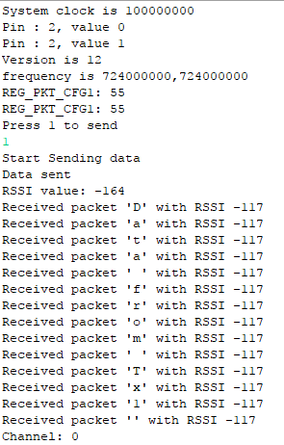

Figure 16: Node $N_{i}$ console output (part 1)

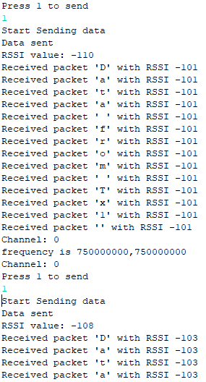

Figure 17: Node $N_{i}$ console output (part 2)

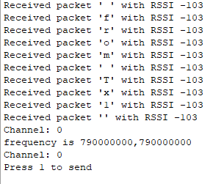

Figure 18: Node $N_{i}$ console output (part 3)

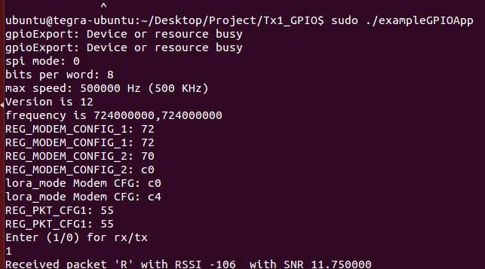

Figure 19: Node $N_{j}$ console output (part 1)

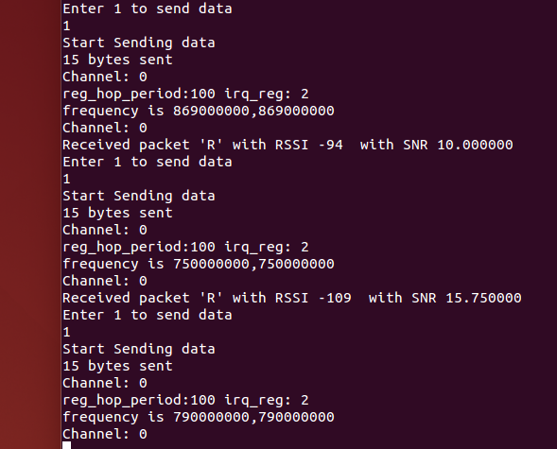

Figure 20: Node $N_{j}$ console output (part 2)

# Conclusion

The objectives of the lab to implement wireless capabilities on LPCXpresso1769 microcontroller were satisfied by being able to send and receive data wirelessly using 433MHz TX/RX RF modules. Sending and receiving had to start at the same time or else it would not work. The interrupt on the receiver node also kept triggering because of random noise. Only one transmitter can be powered on or else the receiver will receive noise from other transmitter node, which will cause data corruption on the receiver node.

The objective of interfacing with SX1276 LoRa module and implement cognitive radio were also satisfied by being able to successfully hop between frequencies for each transmission and reception. Using LoRa is advantageous because of its long range capabilities with high interference immunity.

# References

[1] NXP Semiconductors, LPCXpresso1769 datasheet.

[2] SEMTECH, SX1276-7-8 datasheet.

# Appendix

**Appendix A: Source Code**

**Source Code for Lab1.c**

/*

===============================================================================

Name : Lab1.c

Author : $YuYu Chen

Version :

Copyright : $(copyright)

Description : Lab 1 for CMPE245, Demoed, RX/TX, LISA, De/Scrambler, RF

TODO: implement timer1 peripheral for delay function, timer0 used for interrupt driven timer

===============================================================================

*/

#ifdef __USE_CMSIS

#include "LPC17xx.h"

#endif

#include <cr_section_macros.h>

#include <stdio.h>

#include <stdbool.h>

#include <stdint.h>

#include <string.h>

#define DEBUG 0

#define POLL_RX 0

#define POLL_TX 0

#define PAYLOAD_SIZE 88

#define SYNC_SIZE 256

#define RX_BUFFER_SIZE 1024

#define PAYLOAD_BUFFER_SIZE 256

// firmware

void start_timer(void);

bool enable_timer(uint32_t ms_delay);

void delayMs(uint32_t ms_delay);

void enable_interrupt(void);

void disable_interrupt(void);

// LISA

void decode_payload(void);

void set_confidence(void);

bool match_and_get_payload(void); // LISA algorithm

int sync(int p);

// scrambler/descrambler

void set_scramble_scramble_nth_order(void);

void scramble(int *payload);

void descramble(int *payload);

int syncdata[SYNC_SIZE] = {

1,0,1,0,0,0,0,0, //A prefix

1,0,1,0,0,0,0,1, //0xA1

1,0,1,0,0,0,1,0, //0xA2

1,0,1,0,0,0,1,1, //0xA3

1,0,1,0,0,1,0,0, //0xA4

1,0,1,0,0,1,0,1, //0xA5

1,0,1,0,0,1,1,0, //0xA6

1,0,1,0,0,1,1,1, //0xA7

1,0,1,0,1,0,0,0, //0xA8

1,0,1,0,1,0,0,1, //0xA9

1,0,1,0,1,0,1,0, //0xAA

1,0,1,0,1,0,1,1, //0xAB

1,0,1,0,1,1,0,0, //0xAC

1,0,1,0,1,1,0,1, //0xAD

1,0,1,0,1,1,1,0, //0xAE

1,0,1,0,1,1,1,1, //0xAF

0,1,0,1,0,0,0,0, //5 prefix

0,1,0,1,0,0,0,1, //0x51

0,1,0,1,0,0,1,0, //0x52

0,1,0,1,0,0,1,1, //0x53

0,1,0,1,0,1,0,0, //0x54

0,1,0,1,0,1,0,1, //0x55

0,1,0,1,0,1,1,0, //0x56

0,1,0,1,0,1,1,1, //0x57

0,1,0,1,1,0,0,0, //0x58

0,1,0,1,1,0,0,1, //0x59

0,1,0,1,1,0,1,0, //0x5A

0,1,0,1,1,0,1,1, //0x5B

0,1,0,1,1,1,0,0, //0x5C

0,1,0,1,1,1,0,1, //0x5D

0,1,0,1,1,1,1,0, //0x5E

0,1,0,1,1,1,1,1 //0x5F

};

int payload[PAYLOAD_SIZE] =

{

0,1,1,0,1,0,0,0, // h

0,1,1,0,0,1,0,1, // e

0,1,1,0,1,1,0,0, // l

0,1,1,0,1,1,0,0, // l

0,1,1,0,1,1,1,1, // o

0,0,1,0,0,0,0,0, // _

0,1,1,1,0,1,1,1, // w

0,1,1,0,1,1,1,1, // o

0,1,1,1,0,0,1,0, // r

0,1,1,0,1,1,0,0, // l

0,1,1,0,0,1,0,0, // d

};

int rx_buffer[RX_BUFFER_SIZE] = {0};

int payload_buffer[PAYLOAD_BUFFER_SIZE] = {0};

char decoded_payload[PAYLOAD_BUFFER_SIZE] = {'\0'};

int message_to_send[SYNC_SIZE + PAYLOAD_SIZE] = {0};

static uint8_t confidence = 0;

static int jump =0;

static int prev_jump =0;

volatile bool intr_triggered = false;

volatile bool rx_busy = false;

static int rx_buffer_index = 0;

volatile bool tx_busy = false;

static int tx_buffer_index = 0;

// scrambler

static uint8_t delay_nth_first[PAYLOAD_SIZE] = {0};

static uint8_t delay_nth_second[PAYLOAD_SIZE] = {0};

static int scramble_out[PAYLOAD_SIZE] = {0};

static int descramble_out[PAYLOAD_SIZE] = {0};

static int order = 0;

bool init_pins(void)

{

LPC_PINCON->PINSEL4 &= ~(3 << 12); // pin mux set to GPIO Port 2.6

LPC_GPIO2->FIODIR |= (1 << 6); // set GPIO Port 2.6 external LED as output

LPC_PINCON->PINSEL4 &= ~(3 << 14); // pin mux set to GPIO Port 2.7

LPC_GPIO2->FIODIR &= ~(1 << 7); // set GPIO Port 2.7 on external switch as input

LPC_PINCON->PINSEL0 &= ~(3 << 4); // pin mux set to GPIO Port 0.2

LPC_GPIO0->FIODIR |= (1 << 2); // set GPIO Port 0.2 as TX

LPC_PINCON->PINSEL0 &= ~(3 << 6); // pin mux set to GPIO Port 0.3

LPC_GPIO0->FIODIR &= ~(1 << 3); // set GPIO Port 0.3 RX

// enable_interrupt();

disable_interrupt();

return true;

}

void EINT3_IRQHandler(void)

{

if((LPC_GPIOINT->IO0IntStatR & (1 << 3)) || LPC_GPIOINT->IO0IntStatF & (1 << 3))

{

intr_triggered = true;

}

// Clear the status register of interrupt on P0.3

LPC_GPIOINT->IO0IntClr |= (1 << 3);

}

void enable_interrupt(void)

{

LPC_GPIOINT->IO0IntEnR |= (1 << 3); // rising edge of P0.3

LPC_GPIOINT->IO0IntEnF |= (1 << 3); // falling edge of P0.3

}

void disable_interrupt(void)

{

LPC_GPIOINT->IO0IntEnR = 0x0; // disable rising edge

LPC_GPIOINT->IO0IntEnF = 0x0; // disable falling edge

}

bool init_timer(void)

{

LPC_SC->PCONP |= (1 << 1); // Power up timer0

// LPC_SC->PCLKSEL0 &= ~(3 << 2);

// LPC_SC->PCLKSEL0 |= (1 << 2); // PCLK_peripheral = CCLK

LPC_TIM0->PR = (SystemCoreClock / 4000) -1;

LPC_TIM0->TCR = (0 << 0); // Initially disable counting

return true;

}

// polling, need to change to timer1

bool tx_data(int *sync, int *data)

{

int i;

int message_to_send[SYNC_SIZE + PAYLOAD_SIZE] = {0};

bool success = false;

int success_count = 0;

scramble(data);

// Message to Send out of TX

for(i=0; i < SYNC_SIZE+ PAYLOAD_SIZE; i++)

{

message_to_send[i] = sync[i];

}

for(i = SYNC_SIZE; i < SYNC_SIZE + PAYLOAD_SIZE; i++)

{

message_to_send[i] = scramble_out[i-SYNC_SIZE];

}

if(LPC_GPIO2->FIOPIN & (1 << 7))

{

LPC_GPIO2->FIOSET = (1 << 6);

for(int i=0; i < SYNC_SIZE + PAYLOAD_SIZE; i++)

{

if(message_to_send[i] == 1)

{

LPC_GPIO0->FIOSET = (1 << 2);

success_count++;

}

else if(message_to_send[i] == 0)

{

LPC_GPIO0->FIOCLR = (1 << 2);

success_count++;

}

delayMs(10);

}

if (success_count == SYNC_SIZE+PAYLOAD_SIZE)

{

success = true;

// enable_interrupt();

}

}

else

{

LPC_GPIO2->FIOCLR = (1 << 6);

}

return success;

}

// interrupt driven based on timer interrupt

bool tx_data_ir(int *sync, int *data)

{

int i;

bool success = false;

int success_count = 0;

scramble(data);

// Message to Send out of TX

for(i=0; i < SYNC_SIZE+ PAYLOAD_SIZE; i++)

{

message_to_send[i] = sync[i];

}

for(i = SYNC_SIZE; i < SYNC_SIZE + PAYLOAD_SIZE; i++)

{

message_to_send[i] = scramble_out[i-SYNC_SIZE];

}

start_timer();

tx_busy = true;

printf("busy: %d\r\n", tx_busy);

while(tx_busy)

{

// wait for it to finish, let interrupt do the job

LPC_GPIO2->FIOSET = (1 << 6);

}

LPC_TIM0->TCR = (0 << 0); // stop timer

LPC_GPIO2->FIOCLR = (1 << 6);

tx_buffer_index = 0;

success = true;

return success;

}

// polling rx with delay

bool rx_data(int *buffer)

{

bool success = false;

enable_interrupt();

uint32_t i=1;

// edge detected

if(intr_triggered)

{

puts("disabling");

disable_interrupt();

intr_triggered = false;

buffer[0] = 1; // edge detected? counts as 1 bit?

puts("1");

// poll rest of data after rising edge

while(i < SYNC_SIZE+PAYLOAD_SIZE)

{

if(LPC_GPIO0->FIOPIN & (1 << 3))

{

buffer[i % RX_BUFFER_SIZE] = 1;

i++;

}

else

{

buffer[i % RX_BUFFER_SIZE] = 0;

i++;

}

delayMs(10);

}

// puts("");

// printf("i: %d\r\n", i);

success = match_and_get_payload();

if(success)

{

decode_payload();

}

}

return success;

}

// interrupt driven based on timer

bool rx_data_ir(int *buffer)

{

bool success = false;

enable_interrupt();

// edge detected

if(intr_triggered)

{

puts("disabling");

disable_interrupt();

intr_triggered = false;

buffer[0] = 1; // edge detected? counts as 1 bit?

start_timer();

rx_busy = true;

printf("busy: %d\r\n", rx_busy);

while(rx_busy)

{

// wait for it to finish, let interrupt do the job

}

LPC_TIM0->TCR = (0 << 0); // stop timer

// puts("");

// printf("i: %d\r\n", rx_buffer_index);

rx_buffer_index = 0;

success = match_and_get_payload();

if(success)

{

decode_payload();

}

}

return success;

}

void set_confidence(void)

{

printf("Please enter a confidence level between 1 and 32\n");

printf("A 1 would lead to a 3%% confidence and 32 would lead to a 100%% confidence\n");

scanf("%d", &confidence);

}

int sync(int p)

{

// look only for 0x5? or 0xA? pattern

if((rx_buffer[p] == rx_buffer[p + 2] && rx_buffer[p + 1] == rx_buffer[p + 3]) &&

(rx_buffer[p] != rx_buffer[p+1] && rx_buffer[p] != rx_buffer[p+3] &&

rx_buffer[p+2] != rx_buffer[p+1] && rx_buffer[p+2] != rx_buffer[p+3]))

{

jump = 8 * rx_buffer[p + 4] + 4 * rx_buffer[p + 5] +

2 * rx_buffer[p + 6] + 1 * rx_buffer[p + 7];

#if DEBUG

printf("jump: %d\r\n", jump);

#endif

// Any sequence of 0x5? or 0xA?

if((jump == (prev_jump + 1)) || (jump == (prev_jump - 15)) || (jump == 0))

{

prev_jump = jump;

#if DEBUG

printf("########prev jump: %d\r\n", prev_jump);

#endif

return 1;

}

else

return 0;

}

else

return 0;

}

bool match_and_get_payload(void)

{

bool success = false;

int position = 0;

int limit = 768-(8*(confidence));

int i = 0;

for(i = 0; i < limit; i++)

{

int match = 0, locate = 0;

position = i;

#if DEBUG

printf("outer position: %d\r\n",position);

#endif

while(match != confidence && position < limit)

{

locate = sync(position);

if(locate == 0)

{

break;

}

match = match + locate;

position = position + 8;

#if DEBUG

printf("inner position: %d\r\n", position);

#endif

}

if(match == confidence)

{

success = true;

break;

}

}

if(success)

{

position = position - 8;

int location = rx_buffer[position + 4] * 8 + rx_buffer[position + 5] * 4 +

rx_buffer[position + 6] * 2 + rx_buffer[position + 7];

if(rx_buffer[position] == 0)

{

printf("You are at location 0x5%x\r\n", location);

location = 128 - (8 * location);

}

if(rx_buffer[position] == 1)

{

printf("You are at location 0xA%x\r\n", location);

location = 256 - (8 * location);

}

int index = position + location;

printf("location: %d position: %d index: %d\r\n", location, position, index);

i=0;

for(int p = index; p < index + PAYLOAD_SIZE; p++)

{

payload_buffer[i] = rx_buffer[p];

i++;

}

}

else

{

puts("No match found");

}

return success;

}

void decode_payload(void)

{

uint8_t bits = 0;

int i;

descramble(payload_buffer);

for(i = 0; i < SYNC_SIZE+PAYLOAD_SIZE; i++) //PAYLOAD_SIZE

{

if(i != 0 && i%8 == 0)

{

int index = i/8 - 1;

decoded_payload[index] = ((char)bits);

bits = 0;

}

else

{

bits = bits <<= 1;

bits = bits | descramble_out[i]; // payload_buffer

}

}

printf("payload: %s\r\n", decoded_payload);

puts("");

}

void TIMER0_IRQHandler(void)

{

if ( LPC_TIM0->IR & (0x1<<0) ) // Check MR0 interrupt flag

{

LPC_TIM0->IR = 0xff;

}

// printf("tick\r\n");

// LPC_GPIO0->FIOPIN ^= (1 << 2);

if(tx_busy)

{

if(message_to_send[tx_buffer_index] == 1)

{

LPC_GPIO0->FIOSET = (1 << 2);

tx_buffer_index++;

}

else if(message_to_send[tx_buffer_index] == 0)

{

LPC_GPIO0->FIOCLR = (1 << 2);

tx_buffer_index++;

}

if(tx_buffer_index == SYNC_SIZE +PAYLOAD_SIZE)

{

tx_busy = false;

}

}

if(rx_busy)

{

if(LPC_GPIO0->FIOPIN & (1 << 3))

{

// printf("1");

rx_buffer[rx_buffer_index % RX_BUFFER_SIZE] = 1;

rx_buffer_index++;

}

else

{

// printf("0");

rx_buffer[rx_buffer_index % RX_BUFFER_SIZE] = 0;

rx_buffer_index++;

}

if(rx_buffer_index == SYNC_SIZE + PAYLOAD_SIZE)

{

rx_busy = false;

}

}

}

bool enable_timer(uint32_t ms_delay)

{

// LPC_TIM0->MCR |= (1<<0) | (1<<1); // enable interrupt, reset tick on MR0

LPC_TIM0->TCR = (1 << 1); // reset timer

LPC_TIM0->PR = 0x00; // set prescaler to zero

LPC_TIM0->MR0 = (ms_delay * (SystemCoreClock/4000)) -1;

LPC_TIM0->IR = 0xff; // reset all interrrupts

// LPC_TIM0->TCR = 1; // start timer

return true;

}

void start_timer(void)

{

LPC_TIM0->MCR |= (1<<0) | (1<<1) | (0<<2); // enable interrupt, reset tick on MR0, do not stop on MR0

LPC_TIM0->TCR = 1; // start timer

}

void delayMs(uint32_t ms_delay)

{

LPC_TIM0->TCR = (1 << 1); // reset timer

LPC_TIM0->PR = 0x00; // set prescaler to zero

LPC_TIM0->MR0 = (ms_delay * (SystemCoreClock/4000)) -1;

LPC_TIM0->IR = 0xff; // reset all interrrupts

LPC_TIM0->MCR = (1 << 2); // stop timer on match

LPC_TIM0->TCR = 1; // start timer

while(LPC_TIM0->TCR & 0x01); // wait until delay time has elapsed

}

void set_scramble_scramble_nth_order(void)

{

printf("Enter what nth order to scramble/descramble payload\r\n");

scanf("%d", &order);

}

void scramble(int *payload)

{

int i=0;

uint8_t scramble_buffer = 0;

int payload_index = 0;

int nth_delay_bit = order/2; // order will be the 2nd delay used

uint16_t delay_buffer = 0;

bool out = 0;

int scramble_out_index = 0;

int delay_nth_first_index = 0;

int delay_nth_second_index = 0;

memset(delay_nth_first, 0, sizeof(delay_nth_first)); // reset delay arrays

memset(delay_nth_second, 0, sizeof(delay_nth_second));

puts("scramble");

while(payload_index < PAYLOAD_SIZE)

{

scramble_buffer = 0; // reset buffer to 0

for(i=7; i >= 0; i--) // copy payload 8 bits at a time into buffer

{

scramble_buffer |= payload[payload_index++] << i;

}

for(i=0; i < 8; i++)

{

delay_nth_first[delay_nth_first_index] = ((delay_buffer & (1 << nth_delay_bit)) >> nth_delay_bit);

delay_nth_second[delay_nth_second_index] = ((delay_buffer & (1 << (order-1))) >> (order-1));

out = delay_nth_first[delay_nth_first_index++] ^ delay_nth_second[delay_nth_second_index++]; // delays

out ^= ((scramble_buffer >> (7-i)) & 0x1); // xor with input

scramble_out[scramble_out_index++] = out;

delay_buffer = (delay_buffer << 1) | (out << 0);

}

}

printf("index: %d scrambler_buffer: 0x%x\r\n",payload_index, scramble_buffer);

printf("first: %d second: %d scramble_index: %d\r\n", delay_nth_first_index, delay_nth_second_index, scramble_out_index);

printf("delay_buffer: %d\r\n", delay_buffer);

printf("pay: ");

for(i=0; i < PAYLOAD_SIZE; i++)

{

printf("%d",payload[i]);

}

puts("\r");

printf("D5t: ");

for(i=0; i < PAYLOAD_SIZE; i++)

{

printf("%d",delay_nth_second[i]);

}

puts("\r");

printf("D3t: ");

for(i=0; i < PAYLOAD_SIZE; i++)

{

printf("%d",delay_nth_first[i]);

}

puts("\r");

printf("out: ");

for(i=0; i < PAYLOAD_SIZE; i++)

{

printf("%d",scramble_out[i]);

}

puts("\r");

}

void descramble(int *payload)

{

int i=0;

uint8_t descramble_buffer = 0;

int payload_index = 0;

int nth_delay_bit = order/2; // order will be the 2nd delay used

uint16_t delay_buffer = 0;

bool out = 0;

int descramble_out_index = 0;

int delay_nth_first_index = 0;

int delay_nth_second_index = 0;

memset(delay_nth_first, 0, sizeof(delay_nth_first)); // reset delay arrays

memset(delay_nth_second, 0, sizeof(delay_nth_second));

puts("descramble");

while(payload_index < PAYLOAD_SIZE)

{

descramble_buffer = 0; //reset 8-bit buffer

for(i=7; i >=0; i--)

{

descramble_buffer |= payload[payload_index++] << i;

}

for(i=0; i < 8; i++)

{

delay_nth_first[delay_nth_first_index] = ((delay_buffer & (1 << nth_delay_bit)) >> nth_delay_bit);

delay_nth_second[delay_nth_second_index] = ((delay_buffer & (1 << (order-1))) >> (order-1));

out = delay_nth_first[delay_nth_first_index++] ^ delay_nth_second[delay_nth_second_index++]; // delays

out ^= ((descramble_buffer >> (7-i)) & 0x1); // xor with input

descramble_out[descramble_out_index++] = out;

delay_buffer = (delay_buffer << 1) | (((descramble_buffer >> (7-i)) & 0x1) << 0);

}

}

printf("index: %d scrambler_buffer: 0x%x\r\n",payload_index, descramble_buffer);

printf("first: %d second: %d scramble_index: %d\r\n", delay_nth_first_index, delay_nth_second_index, descramble_out_index);

printf("delay_buffer: %d\r\n", delay_buffer);

printf("pay: ");

for(i=0; i < PAYLOAD_SIZE; i++)

{

printf("%d",payload[i]);

}

puts("\r");

printf("D5t: ");

for(i=0; i < PAYLOAD_SIZE; i++)

{

printf("%d",delay_nth_second[i]);

}

puts("\r");

printf("D3t: ");

for(i=0; i < PAYLOAD_SIZE; i++)

{

printf("%d",delay_nth_first[i]);

}

puts("\r");

printf("out: ");

for(i=0; i < PAYLOAD_SIZE; i++)

{

printf("%d",descramble_out[i]);

}

puts("\r");

}

int main(void) {

int option =0;

bool success;

bool success1;

printf("Hello World\n");

init_pins();

init_timer();

#if !(POLL_RX)

enable_timer(10);

#endif

NVIC_EnableIRQ(TIMER0_IRQn);

NVIC_EnableIRQ(EINT3_IRQn);

set_confidence();

set_scramble_scramble_nth_order();

while(1)

{

printf("Option1: send data Option2: receive data\r\n");

scanf( "%d", &option);

switch(option)

{

case 1:

#if POLL_TX

success = tx_data(syncdata, payload);

#else

success = tx_data_ir(syncdata, payload);

#endif

printf("success: %d\r\n", success);

break;

case 2:

#if POLL_RX

success1 = rx_data(rx_buffer);

printf("success1: %d\r\n", success1);

#else

success1 = rx_data_ir(rx_buffer);

printf("success1: %d\r\n", success1);

#endif

break;

case 3:

scramble(payload);

descramble(scramble_out);

break;

default:

success = tx_data(syncdata, payload);

printf("success: %d\r\n", success);

break;

}

// delayMs(1000);

// LPC_GPIO0->FIOPIN ^= (1 << 2);

// delayMs(100);

// success1 = rx_data_ir(rx_buffer);

// printf("success1: %d\r\n", success1);

}

return 0 ;

}

**Source Code for main_lora.c**

/*

===============================================================================

Name : Cognitive_Radio.c

Author : $(author)

Version :

Copyright : $(copyright)

Description : main definition

===============================================================================

*/

/*

===============================================================================

Name : RF_Handshaking.c

Description : RF and PWM code for LPC1769

CTI One Corporation released for Dr. Harry Li for CMPE 245 Class use ONLY!

===============================================================================

*/

#ifdef __USE_CMSIS

#include "LPC17xx.h"

#endif

#include <cr_section_macros.h>

#include <stdio.h>

#include <stdbool.h>

#include "LoRa.h"

#include"common.h"

#define RF_Receive 0

#define TransmittACk 1

#define CAD 0

#define ack_start_stop 0

int rfInit(void);

char receiveData=0;

int packetSize;

long LUT[7]={ 869000000,

//724000000,

750000000,

790000000,

800000000,

845000000,

850000000,

869000000};

/**************************************************************************************************

* @brief wait for ms amount of milliseconds

* @param ms : Time to wait in milliseconds

**************************************************************************************************/

static void delay_ms(unsigned int ms)

{

unsigned int i,j;

for(i=0;i<ms;i++)

for(j=0;j<50000;j++);

}

/**************************************************************************************************

* @brief wait for delayInMs amount of milliseconds

* @param delayInMs : Time to wait in milliseconds

**************************************************************************************************/

static void delay(uint32_t delayInMs)

{

LPC_TIM0->TCR = 0x02; /* reset timer */

LPC_TIM0->PR = 0x00; /* set prescaler to zero */

LPC_TIM0->MR0 = delayInMs * (9000000 / 1000-1);

LPC_TIM0->IR = 0xff; /* reset all interrrupts */

LPC_TIM0->MCR = 0x04; /* stop timer on match */

LPC_TIM0->TCR = 0x01; /* start timer */

/* wait until delay time has elapsed */

while (LPC_TIM0->TCR & 0x01);

}

/**************************************************************************************************

* main : Main program entry

**************************************************************************************************/

int main(void)

{

printf("System clock is %d\n",SystemCoreClock);

// Working frequency range from 724 MHz to 1040 MHz.

//LoRabegin(1040000000);

//LoRabegin(1020000000);

LoRabegin(724000000);

//LoRabegin(750000000);

//LoRabegin(790000000);

//LoRabegin(800000000);

//LoRabegin(845000000);

//LoRabegin(850000000);

//LoRabegin(910000000);

//LoRabegin(869000000);

//LoRabegin(915000000);

//LoRabegin(169000000);

int counter = 0, transmit_counter = 0, freq_counter = 0;

int received = 0, send = 0, payload = 0;

//timer_initialise();

//share_and_address_filter();

crc();

/* Start the tasks running. */

//vTaskStartScheduler();

setSignalBandwidth(125E3);

setSpreadingFactor(12);

setCodingRate4(5);

set_freq_hop_period(100);

writeRegister(0x01, readRegister(0x01) & (~(1 << 7)| ~(0x7 <<0))); // aShare FSK address space (0x0D:0x3F)

writeRegister(0x01, readRegister(0x01) | (1 << 6)); // Share FSK address space (0x0D:0x3F)

printf("REG_PKT_CFG1: %x\n", readRegister(0x30));

enableScrambling(); // 9. Scramble

printf("REG_PKT_CFG1: %x\n", readRegister(0x30));

//enableBeacon(); // 10.Beacon (Only for fixed length packet format)

// 13. Channel Filter: RxBw = 10.4 Bit Rate 4.8 kbps (Note: BitRate < 2 x RxBw)

/*printf("FSK_mode Pkt CFG: %x\n", readRegister(REG_PKT_CFG1));

fsk_mode_crc_enable(); // Its enabled by default

printf("FSK_mode Pkt CFG: %x\n", readRegister(REG_PKT_CFG1));*/

// 8. ADR: address based communication

writeRegister(REG_SYNC_CFG, readRegister(REG_SYNC_CFG) | (1 << 4)); // Set SYNC on

writeRegister(REG_PKT_CFG1, readRegister(REG_PKT_CFG1) | (1 << 2)); // Set Address filtering (Address field must match node address or broadcast address)

setNodeAddress(0x51);

setBroadCastAddress(0xA1);

// Sync

writeRegister(0x27, readRegister(0x27) | (1 << 4) | (3 << 0));

writeRegister(0x28, 0x50);

writeRegister(0x29, 0x51);

writeRegister(0x2A, 0x52);

writeRegister(0x2B, 0x53);

writeRegister(0x01, readRegister(0x01) | (1 << 6)); // Switch to LoRa mode

sleep();

/* If all is well we will never reach here as the scheduler will now be

running. If we do reach here then it is likely that there was insufficient

heap available for the idle task to be created. */

#if RF_Receive

while(1)

{

#if CAD

int success = 0;

success = CAD_process();

if(success == 1)

{

#endif

packetSize = parsePacket(0);

if (packetSize)

{

counter = 0;

//NVIC_EnableIRQ(TIMER0_IRQn);

//received a packet

// printf("Received packet '");

// read packet

while (available())

{

counter = 0;

receiveData = read();

printf("Received packet '");

printf("%c",receiveData);

printf("' with RSSI ");

printf("%d\n",packetRssi());

}

// print RSSI of packet

printf("Received packet '");

printf("%c",receiveData);

printf("' with RSSI ");

printf("%d\n",packetRssi());

}

#if CAD

}

#endif

}

#endif

#if TransmittACk

const char buffer[] = "2R";

char Acknowledgement;

Acknowledgement = 'A';

while(1)

{

if(received)

{

int channel = get_fhss_present_channel();

printf("Channel: %d\n", channel);

setFrequency(LUT[freq_counter]);

freq_counter++;

if(freq_counter == 7)

freq_counter = 0;

printf("Channel: %d\n", channel);

received = 0;

}

printf("Press 1 to send\n");

if(scanf("%d",&send) == 1)

{

printf("Start Sending data \n");

delay_ms(1000);

LoRabeginPacket(0);

//writebyte(Acknowledgement);

write(buffer, sizeof(buffer));

LoRaendPacket();

printf("Data sent \n");

printf("RSSI value: %d\n", packetRssi());

}

while(1)

{

packetSize = parsePacket(0);

if (packetSize)

{

while (available())

{

receiveData = read();

if(receiveData=='5')

{

payload = 1;

}

else if(payload)

{

printf("Received packet '");

printf("%c",receiveData);

printf("' with RSSI ");

printf("%d\n",packetRssi());

received = 1;

}

}

payload = 0;

break;

}

}

}

#endif

}

void check_ack()

{

printf("1 \n");

// NVIC_EnableIRQ(TIMER0_IRQn);

//NVIC_DisableIRQ(TIMER0_IRQn);

}

**Source Code for LoRa.h**

/*

* LoRa.h

*

* Created on: Dec 8, 2017

* Author: Jeremy

*/

/*

* LoRa.h

*

* Created on: Oct 29, 2017

* CTI One Corporation released for Dr. Harry Li for CMPE 245 Class use ONLY!

*/

#ifndef LORA_H_

#define LORA_H_

/*

* LoRa.h

*

* Created on: Oct 29, 2017

* CTI One Corporation released for Dr. Harry Li for CMPE 245 Class use ONLY!

*/

#include <stddef.h>

#include "ssp.h"

//#define LORA_DEFAULT_SS_PIN 10

#define LORA_DEFAULT_RESET_PIN 2

#define LORA_DEFAULT_DIO0_PIN 3

int LoRabegin(long frequency);

void end();

int LoRabeginPacket(int implicitHeader);

int LoRaendPacket();

int parsePacket(int size );

int packetRssi();

float packetSnr();

// from Print

size_t writebyte(uint8_t byte);

size_t write(const uint8_t *buffer, size_t size);

// from Stream

int available();

int read();

int peek();

void flush();

void onReceive(void(*callback)(int));

void receive(int size);

void idle();

void sleep();

void setTxPower(int level);

void setFrequency(long frequency);

void setSpreadingFactor(int sf);

void setSignalBandwidth(long sbw);

void setCodingRate4(int denominator);

void setPreambleLength(long length);

void setSyncWord(int sw);

void crc();

void noCrc();

uint8_t random();

// void dumpRegisters(Stream& out);

uint8_t readRegister(uint8_t address);

void explicitHeaderMode();

void implicitHeaderMode();

void handleDio0Rise();

void writeRegister(uint8_t address, uint8_t value);

uint8_t singleTransfer(uint8_t address, uint8_t value);

static void onDio0Rise();

int CAD_process(void);

int check_fhss_channel_change(long freq);

uint8_t get_fhss_present_channel(void);

int set_freq_hop_period(uint8_t freq_hop_period);

void digitalWrite(uint8_t pin, uint8_t value);

void gpioInit();

void setBroadCastAddress(uint8_t addr);

void setNodeAddress(uint8_t addr);

#define ADDR_FILTER_MODE1 0x01

#define ADDR_FILTER_MODE2 0x02

#define REG_SYNC_CFG 0x27

#define REG_NODE_ADRS 0x33

#define REG_BROADCAST_ADDR 0x34

#define REG_PKT_CFG1 0x30

#define REG_PKT_CFG2 0x31

#endif /* LORA_H_ */

**Source Code for LoRa.c**

/*

* LoRa.c

*

* Created on: Dec 8, 2017

* Author: Jeremy

*/

/*

* LoRa.c

*

* Created on: Oct 29, 2017

* CTI One Corporation released for Dr. Harry Li for CMPE 245 Class use ONLY!

*/

/*

* LoRa.cpp

*

* Created on: Oct 29, 2017

* CTI One Corporation released for Dr. Harry Li for CMPE 245 Class use ONLY!

*/

#include <stdio.h>

#include <stddef.h>

#include "LoRa.h"

#include "ssp.h"

#include "extint.h"

// registers

#define REG_BITRATE_MSB 0x02

#define REG_BITRATE_LSB 0x03

#define REG_FIFO 0x00

#define REG_OP_MODE 0x01

#define REG_FRF_MSB 0x06

#define REG_FRF_MID 0x07

#define REG_FRF_LSB 0x08

#define REG_PA_CONFIG 0x09

#define REG_LNA 0x0c

#define REG_FIFO_ADDR_PTR 0x0d

#define REG_FIFO_TX_BASE_ADDR 0x0e

#define REG_FIFO_RX_BASE_ADDR 0x0f

#define REG_FIFO_RX_CURRENT_ADDR 0x10

#define REG_IRQ_FLAGS 0x12

#define REG_RX_NB_BYTES 0x13

#define REG_PKT_RSSI_VALUE 0x1a

#define REG_PKT_SNR_VALUE 0x1b

#define REG_MODEM_CONFIG_1 0x1d

#define REG_MODEM_CONFIG_2 0x1e

#define REG_PREAMBLE_MSB 0x20

#define REG_PREAMBLE_LSB 0x21

#define REG_PAYLOAD_LENGTH 0x22

#define REG_RSSI_WIDEBAND 0x2c

#define REG_DETECTION_OPTIMIZE 0x31

#define REG_DETECTION_THRESHOLD 0x37

#define REG_SYNC_WORD 0x39

#define REG_DIO_MAPPING_1 0x40

#define REG_VERSION 0x42

#define REG_HOP_CHANNEL 0x1C

#define REG_HOP_PERIOD 0x24

#define REG_PACKET_CONFIG1 0x30

// modes

#define MODE_LONG_RANGE_MODE 0x80

#define MODE_SLEEP 0x00

#define MODE_STDBY 0x01

#define MODE_TX 0x03

#define MODE_RX_CONTINUOUS 0x05

#define MODE_RX_SINGLE 0x06

#define MODE_CAD 0x07

#define ACCESS_SHARE (1<<6)

#define AddressFiltering (2<<1)

// PA config

#define PA_BOOST 0x80

// IRQ masks

#define IRQ_TX_DONE_MASK 0x08

#define IRQ_PAYLOAD_CRC_ERROR_MASK 0x20

#define IRQ_RX_DONE_MASK 0x40

#define IRQ_CAD_DONE (1 << 2)

#define IRQ_FHSS_CHANNEL_CHANGE (1 << 1)

#define IRQ_CAD_DETECTED (1 << 0)

#define FHSS_PRESENT_CHANNEL 0x3F

#define MAX_PKT_LENGTH 255

#define LOW 0

#define HIGH 1

#define ADDR_FILTER_MODE1 0x01

#define ADDR_FILTER_MODE2 0x02

#define REG_SYNC_CFG 0x27

#define REG_NODE_ADRS 0x33

#define REG_BROADCAST_ADDR 0x34

#define REG_PKT_CFG1 0x30

#define REG_PKT_CFG2 0x31

#define function_not_required 0

int _packetIndex=0;

int _implicitHeaderMode=0;

int _frequency=0;

#if function_not_required

void (*_onReceive)(int);

#endif

char receiveLora=0;

#if function_not_required

void onReceivedata(int packetSize) {

// received a packet

printf("Received packet ");

int i=0;

// read packet

for (i = 0; i < packetSize; i++) {

printf("%c\n",(char)read());

}

// print RSSI of packet

print("' with RSSI ",packetRssi());

}

void EINT3_IRQHandler(void)

{

LPC_SC->EXTINT = EINT3; /* clear interrupt */

printf("Interrupt triggered\n");

// Toggle Led On

//LPC_GPIO0->FIOPIN ^= (1<<2);

handleDio0Rise();

/*Clear interrupts */

LPC_GPIOINT->IO0IntClr = 0xFFFFFFFF;

}

#endif

void gpioInit()

{

// Select P0.2 as GPIO for RESET

LPC_PINCON->PINSEL0 &= ~(3<<4);

// P0.3 as GPIO

LPC_PINCON->PINSEL0 &= ~(3<<6);

// P0.2 as output For RESET

LPC_GPIO0->FIODIR |= (1<<2);

// P0.3 as input For DIO0

//LPC_GPIO0->FIODIR &= ~(1<<3);

//LPC_GPIOINT->IO0IntEnR |= (1<<3);

//NVIC_EnableIRQ(EINT3_IRQn);

}

void digitalWrite(uint8_t pin, uint8_t value)

{

printf("Pin : %d, value %d\n",pin,value);

if(value == 1)

{

LPC_GPIO0->FIOPIN |= (1<<pin);

}

else if(value == 0)

{

LPC_GPIO0->FIOPIN &= ~(1<<pin);

}

}

int LoRabegin(long frequency)

{

// setup pins

uint8_t version =0;

int i=0;

gpioInit();

// perform reset

digitalWrite(LORA_DEFAULT_RESET_PIN, LOW);

for(i=0;i<100000;i++);

digitalWrite(LORA_DEFAULT_RESET_PIN, HIGH);

for(i=0;i<10000000;i++);

// set SS high

CHIP_DESELECT();

//digitalWrite(_ss, HIGH);

SSP1Init();

// start SPI

//SPI.begin();

// check version

version = readRegister(REG_VERSION);

printf("Version is %x\n",version);

if (version != 0x12) {

return 0;

}

// put in sleep mode

sleep();

// set frequency

setFrequency(frequency);

// set base addresses

writeRegister(REG_FIFO_TX_BASE_ADDR, 0);

writeRegister(REG_FIFO_RX_BASE_ADDR, 0);

// set LNA boost

writeRegister(REG_LNA, readRegister(REG_LNA) | 0x03);

// set output power to 17 dBm

setTxPower(17);

// put in standby mode

idle();

return 1;

}

void end()

{

// put in sleep mode

sleep();

// stop SPI

//SPI.end();

}

int LoRabeginPacket(int implicitHeader)

{

// put in standby mode

idle();

if (implicitHeader)

{

implicitHeaderMode();

}

else {

explicitHeaderMode();

}

// reset FIFO address and payload length

writeRegister(REG_FIFO_ADDR_PTR, 0);

writeRegister(REG_PAYLOAD_LENGTH, 0);

return 1;

}

int LoRaendPacket()

{

uint8_t rOut=0;

// put in TX mode

writeRegister(REG_OP_MODE, MODE_LONG_RANGE_MODE | MODE_TX);

// wait for TX done

while((readRegister(REG_IRQ_FLAGS) & IRQ_TX_DONE_MASK) == 0);

// clear IRQ's

writeRegister(REG_IRQ_FLAGS, IRQ_TX_DONE_MASK);

return 1;

}

int parsePacket(int size)

{

int packetLength = 0;

int irqFlags = readRegister(REG_IRQ_FLAGS);

if (size > 0)

{

implicitHeaderMode();

writeRegister(REG_PAYLOAD_LENGTH, size & 0xff);

}

else

{

explicitHeaderMode();

}

// clear IRQ's

writeRegister(REG_IRQ_FLAGS, irqFlags);

if ((irqFlags & IRQ_RX_DONE_MASK) && (irqFlags & IRQ_PAYLOAD_CRC_ERROR_MASK) == 0)

{

// received a packet

_packetIndex = 0;

// read packet length

if (_implicitHeaderMode)

{

packetLength = readRegister(REG_PAYLOAD_LENGTH);

}

else

{

packetLength = readRegister(REG_RX_NB_BYTES);

}

// set FIFO address to current RX address

writeRegister(REG_FIFO_ADDR_PTR, readRegister(REG_FIFO_RX_CURRENT_ADDR));

// put in standby mode

idle();

}

else if (readRegister(REG_OP_MODE) != (MODE_LONG_RANGE_MODE | MODE_RX_SINGLE))

{

// not currently in RX mode

// reset FIFO address

writeRegister(REG_FIFO_ADDR_PTR, 0);

// put in single RX mode

writeRegister(REG_OP_MODE, MODE_LONG_RANGE_MODE | MODE_RX_SINGLE);

}

return packetLength;

}

int packetRssi()

{

return (readRegister(REG_PKT_RSSI_VALUE) - (_frequency < 868E6 ? 164 : 157));

}

float packetSnr()

{

return ((int8_t)readRegister(REG_PKT_SNR_VALUE)) * 0.25;

}

size_t writebyte(uint8_t byte)

{

return write(&byte, sizeof(byte));

}

size_t write(const uint8_t *buffer, size_t size)

{

int currentLength = readRegister(REG_PAYLOAD_LENGTH);

size_t i=0;

// check size

if ((currentLength + size) > MAX_PKT_LENGTH)

{

size = MAX_PKT_LENGTH - currentLength;

}

// write data

for (i = 0; i < size; i++)

{

writeRegister(REG_FIFO, buffer[i]);

}

// update length

writeRegister(REG_PAYLOAD_LENGTH, currentLength + size);

return size;

}

int available()

{

return (readRegister(REG_RX_NB_BYTES) - _packetIndex);

}

int read()

{

if (!available()) {

return -1;

}

_packetIndex++;

return readRegister(REG_FIFO);

}

int peek()

{

if (!available()) {

return -1;

}

// store current FIFO address

int currentAddress = readRegister(REG_FIFO_ADDR_PTR);

// read

uint8_t b = readRegister(REG_FIFO);

// restore FIFO address

writeRegister(REG_FIFO_ADDR_PTR, currentAddress);

return b;

}

void flush()

{

}

#if function_not_required

void onReceive(void(*callback)(int))

{

_onReceive = callback;

//writeRegister(REG_DIO_MAPPING_1, 0x00);

if (callback)

{

writeRegister(REG_DIO_MAPPING_1, 0x00);

//attachInterrupt(digitalPinToInterrupt(_dio0), onDio0Rise, RISING);

}

else

{

//detachInterrupt(digitalPinToInterrupt(_dio0));

}

}

void receive(int size)

{

if (size > 0)

{

implicitHeaderMode();

writeRegister(REG_PAYLOAD_LENGTH, size & 0xff);

}

else

{

explicitHeaderMode();

}

writeRegister(REG_OP_MODE, MODE_LONG_RANGE_MODE | MODE_RX_CONTINUOUS);

}

#endif

void idle()

{

writeRegister(REG_OP_MODE, MODE_LONG_RANGE_MODE | MODE_STDBY);

}

void sleep()

{

writeRegister(REG_OP_MODE, MODE_LONG_RANGE_MODE | MODE_SLEEP);

}

void setTxPower(int level)

{

if (level < 2)

{

level = 2;

}

else if (level > 17)

{

level = 17;

}

writeRegister(REG_PA_CONFIG, PA_BOOST | (level - 2));

}

void setFrequency(long frequency)

{

_frequency = frequency;

printf("frequency is %d,%d\n",frequency,_frequency);

uint64_t frf = ((uint64_t)frequency << 19) / 32000000;

writeRegister(REG_FRF_MSB, (uint8_t)(frf >> 16));

writeRegister(REG_FRF_MID, (uint8_t)(frf >> 8));

writeRegister(REG_FRF_LSB, (uint8_t)(frf >> 0));

}

void setSpreadingFactor(int sf)

{

if (sf < 6)

{

sf = 6;

}

else if (sf > 12)

{

sf = 12;

}

if (sf == 6)

{

writeRegister(REG_DETECTION_OPTIMIZE, 0xc5);

writeRegister(REG_DETECTION_THRESHOLD, 0x0c);

}

else

{

writeRegister(REG_DETECTION_OPTIMIZE, 0xc3);

writeRegister(REG_DETECTION_THRESHOLD, 0x0a);

}

writeRegister(REG_MODEM_CONFIG_2, (readRegister(REG_MODEM_CONFIG_2) & 0x0f) | ((sf << 4) & 0xf0));

}

void setSignalBandwidth(long sbw)

{

int bw;

if (sbw <= 7.8E3) {

bw = 0;

} else if (sbw <= 10.4E3) {

bw = 1;

} else if (sbw <= 15.6E3) {

bw = 2;

} else if (sbw <= 20.8E3) {

bw = 3;

} else if (sbw <= 31.25E3) {

bw = 4;

} else if (sbw <= 41.7E3) {

bw = 5;

} else if (sbw <= 62.5E3) {

bw = 6;

} else if (sbw <= 125E3) {

bw = 7;

} else if (sbw <= 250E3) {

bw = 8;

} else /*if (sbw <= 250E3)*/ {

bw = 9;

}

writeRegister(REG_MODEM_CONFIG_1, (readRegister(REG_MODEM_CONFIG_1) & 0x0f) | (bw << 4));

}

void setCodingRate4(int denominator)

{

if (denominator < 5) {

denominator = 5;

} else if (denominator > 8) {

denominator = 8;

}

int cr = denominator - 4;

writeRegister(REG_MODEM_CONFIG_1, (readRegister(REG_MODEM_CONFIG_1) & 0xf1) | (cr << 1));

}

void setPreambleLength(long length)

{

writeRegister(REG_PREAMBLE_MSB, (uint8_t)(length >> 8));

writeRegister(REG_PREAMBLE_LSB, (uint8_t)(length >> 0));

}

void setSyncWord(int sw)

{

writeRegister(REG_SYNC_WORD, sw);

}

void crc()

{

writeRegister(REG_MODEM_CONFIG_2, readRegister(REG_MODEM_CONFIG_2) | 0x04);

}

void noCrc()

{

writeRegister(REG_MODEM_CONFIG_2, readRegister(REG_MODEM_CONFIG_2) & 0xfb);

}

uint8_t random()

{

return readRegister(REG_RSSI_WIDEBAND);

}

/*

void setPins(int ss, int reset, int dio0)

{

_ss = ss;

_reset = reset;

_dio0 = dio0;

}

void dumpRegisters(Stream& out)

{

for (int i = 0; i < 128; i++) {

out.print("0x");

out.print(i, HEX);

out.print(": 0x");

out.println(readRegister(i), HEX);

}

}

*/

void explicitHeaderMode()

{

_implicitHeaderMode = 0;

writeRegister(REG_MODEM_CONFIG_1, readRegister(REG_MODEM_CONFIG_1) & 0xfe);

}

void implicitHeaderMode()

{

_implicitHeaderMode = 1;

writeRegister(REG_MODEM_CONFIG_1, readRegister(REG_MODEM_CONFIG_1) | 0x01);

}

#if function_not_required

void handleDio0Rise()

{

int irqFlags = readRegister(REG_IRQ_FLAGS);

int i=0;

// clear IRQ's

writeRegister(REG_IRQ_FLAGS, irqFlags);

if ((irqFlags & IRQ_PAYLOAD_CRC_ERROR_MASK) == 0) {

// received a packet

_packetIndex = 0;

// read packet length

int packetLength = _implicitHeaderMode ? readRegister(REG_PAYLOAD_LENGTH) : readRegister(REG_RX_NB_BYTES);

// set FIFO address to current RX address

writeRegister(REG_FIFO_ADDR_PTR, readRegister(REG_FIFO_RX_CURRENT_ADDR));

// if (_onReceive) {

// _onReceive(packetLength);

// }

for (i = 0; i < packetLength; i++)

{

receiveLora = read();

printf("Receive data is %c\n",receiveLora);

}

// reset FIFO address

writeRegister(REG_FIFO_ADDR_PTR, 0);

}

}

#endif

uint8_t readRegister(uint8_t address)

{

return singleTransfer(address & 0x7f, 0x00);

}

void writeRegister(uint8_t address, uint8_t value)

{

singleTransfer(address | 0x80, value);

}

uint8_t singleTransfer(uint8_t address, uint8_t value)

{

uint8_t response=0;

//digitalWrite(_ss, LOW);

CHIP_SELECT();

//SPI.beginTransaction(_spiSettings);

response = ssp1Transfer(address);

//printf("response %x\n",response);

response = ssp1Transfer(value);

//printf("response %x\n",response);

CHIP_DESELECT();

//digitalWrite(_ss, HIGH);

return response;

}

#if function_not_required

void onDio0Rise()

{

handleDio0Rise();

}

#endif

void share_and_address_filter(void)

{

//switch to FSK mode to change broadcast/node address

writeRegister(REG_OP_MODE, readRegister(REG_OP_MODE)|ACCESS_SHARE);

//Set Address filter to match Node or Broadcast

writeRegister(REG_PACKET_CONFIG1, readRegister(REG_PACKET_CONFIG1)|AddressFiltering);

//Broadcast Address, RegBroadcastAdrs

writeRegister(0x34, readRegister(0x34)|0xA2);

//Node Address

writeRegister(0x33, readRegister(0x33)|0x51);

writeRegister(0x27,readRegister(0x27)|(1<<5));

//Switch back to LORA mode

//writeRegister(REG_OP_MODE, readRegister(REG_OP_MODE)|MODE_LONG_RANGE_MODE);

}

int CAD_process(void)

{

int success = 0;

// put in standby

idle();

// set to CAD mode

writeRegister(REG_OP_MODE, MODE_LONG_RANGE_MODE | MODE_CAD);

// wait for CAD done

while((readRegister(REG_IRQ_FLAGS) & IRQ_CAD_DONE) == 0);

// clear IRQ's

writeRegister(REG_IRQ_FLAGS, IRQ_CAD_DONE);

if((readRegister(REG_IRQ_FLAGS)) & IRQ_CAD_DETECTED)

{

writeRegister(REG_IRQ_FLAGS, IRQ_CAD_DETECTED);

success = 1;

}

return success;

}

int set_freq_hop_period(uint8_t freq_hop_period)

{

// hoppingperiod = Ts * Freq_hopping_period

writeRegister(REG_HOP_PERIOD, freq_hop_period);

return 1;

}

uint8_t get_fhss_present_channel(void)

{

uint8_t channel = readRegister(REG_HOP_CHANNEL);

channel &= FHSS_PRESENT_CHANNEL;

return channel;

}

int check_fhss_channel_change(long freq)

{

// pg 32

int success = 0;

uint8_t irq_reg = readRegister(REG_IRQ_FLAGS);

printf("irq_reg: %x\n", irq_reg);

if(irq_reg & IRQ_FHSS_CHANNEL_CHANGE)

{

setFrequency(freq);

writeRegister(REG_IRQ_FLAGS, IRQ_FHSS_CHANNEL_CHANGE);

success = 1;

}

return success;

}

void freqband(int mode)

{

if(mode)

writeRegister(REG_OP_MODE, readRegister(REG_OP_MODE)|(1<<3));

else

writeRegister(REG_OP_MODE, readRegister(REG_OP_MODE)|(0<<3));

}

void whitening(int mode)

{

if(mode == 1)

{

writeRegister(REG_PACKET_CONFIG1, readRegister(REG_PACKET_CONFIG1)|(1<<5));

}

else if(mode == 2)

{

writeRegister(REG_PACKET_CONFIG1, readRegister(REG_PACKET_CONFIG1)|(1<<6));

}

else

writeRegister(REG_PACKET_CONFIG1, readRegister(REG_PACKET_CONFIG1)|(0<<5));

}

void enableScrambling()

{

writeRegister(REG_PKT_CFG1, readRegister(REG_PKT_CFG1) | 0x40);

}

void enableBeacon()

{

writeRegister(REG_PKT_CFG1, readRegister(REG_PKT_CFG1) & ~(1 << 7)); // Switch to fixed length packet format first in order to set beacon

writeRegister(REG_PKT_CFG2, readRegister(REG_PKT_CFG2) | (1 << 3));

}

void fsk_mode_crc_enable()

{

writeRegister(REG_PKT_CFG1, readRegister(REG_PKT_CFG1) | (1 << 4));

}

void setNodeAddress(uint8_t addr)

{

writeRegister(REG_PKT_CFG1, readRegister(REG_PKT_CFG1) | ADDR_FILTER_MODE2 << 1); //Set address filtering

writeRegister(REG_NODE_ADRS, addr); //Set node address

}

void setBroadCastAddress(uint8_t addr)

{

writeRegister(REG_BROADCAST_ADDR, addr);

}

**Source Code for ssp.c**

/*

* ssp.c

*

* Created on: Dec 8, 2017

* Author: Jeremy

*/

/*

* spi.cpp

*

* Created on: Oct 29, 2017

* CTI One Corporation released for Dr. Harry Li for CMPE 245 Class use ONLY!

*/

#include "ssp.h"

//#define CHIP_SELECT (LPC_GPIO0->FIOCLR |= (0x1<<6))

//#define CHIP_DESELECT (LPC_GPIO0->FIOSET |= (0x1<<6))

#define SSP_BUFSIZE 128

/* statistics of all the interrupts */

volatile uint32_t interrupt0RxStat = 0;

volatile uint32_t interrupt0OverRunStat = 0;

volatile uint32_t interrupt0RxTimeoutStat = 0;

volatile uint32_t interrupt1RxStat = 0;

volatile uint32_t interrupt1OverRunStat = 0;

volatile uint32_t interrupt1RxTimeoutStat = 0;

uint8_t sendBuffer[SSP_BUFSIZE];

/****************************************************************************************

*SSP1_IRQHandler - SSP1 interrupt handler

****************************************************************************************/

void SSP1_IRQHandler(void)

{

uint32_t regValue;

regValue = LPC_SSP1->MIS;

if ( regValue & SSPMIS_RORMIS ) /* Receive overrun interrupt */

{

interrupt1OverRunStat++;

LPC_SSP1->ICR = SSPICR_RORIC; /* clear interrupt */

}

if ( regValue & SSPMIS_RTMIS ) /* Receive timeout interrupt */

{

interrupt1RxTimeoutStat++;

LPC_SSP1->ICR = SSPICR_RTIC; /* clear interrupt */

}

/* please be aware that, in main and ISR, CurrentRxIndex and CurrentTxIndex

are shared as global variables. It may create some race condition that main

and ISR manipulate these variables at the same time. SSPSR_BSY checking (polling)

in both main and ISR could prevent this kind of race condition */

if ( regValue & SSPMIS_RXMIS ) /* Rx at least half full */

{

interrupt1RxStat++; /* receive until it's empty */

}

return;

}

/****************************************************************************************

* SSP1Init - Initialize SSP1 module

****************************************************************************************/

void SSP1Init()

{

// Enable SSP1

LPC_SC->PCONP |= (1 << SSP1_PCONP_ENABLE);

// Clock selection for SSP1

LPC_SC->PCLKSEL0 |= (3<<20);

/* PIN select P0.6 - SSP1 SSEL1, P0.7 - SSP1 SCK1

P0.8 - SSP1 MISO1, P0.9 - SSP1 MOSI1 */

LPC_PINCON->PINSEL0 &= ~((0x3<<12)|(0x3<<14)|(0x3<<16)|(0x3<<18));

LPC_PINCON->PINSEL0 |= ((0x2<<12)|(0x2<<14)|(0x2<<16)|(0x2<<18));

LPC_PINCON->PINSEL0 &= ~(3<<12); //P0.6 as gpio

LPC_GPIO0->FIODIR |= (1<<6); // SSP0 P0.6 defined as Outputs

// DSS data to 8-bit, Frame format SPI, CPOL = 0, CPHA = 0, and SCR is 15

LPC_SSP1->CR0 = 0x0707;

// SSP1 CPSR clock pre-scale register, master mode, minimum divisor is 0x02

LPC_SSP1->CPSR = 0x2;

/* Enable the SSP Interrupt */

NVIC_EnableIRQ(SSP1_IRQn);

/* Master mode */

LPC_SSP1->CR1 &= ~(SSPCR1_MS);

/* SSP Enable */

LPC_SSP1->CR1 = SSPCR1_SSE;

LPC_SSP1->IMSC = SSPIMSC_RORIM | SSPIMSC_RTIM;

}

/****************************************************************************************

* ssp1Send - send data over SSP1

****************************************************************************************/

uint8_t ssp1Send(uint8_t *buf, uint32_t length)

{

uint32_t i=0;

uint8_t Dummy = 0;

for( i = 0 ; i < length ; i++ )

{

/* Move on only if NOT busy and TX FIFO not full. */

while((LPC_SSP1->SR & (SSP_STAT_TNF|SSP_STAT_BSY)) != SSP_STAT_TNF);

LPC_SSP1->DR = *buf;

buf++;

while((LPC_SSP1->SR & (SSP_STAT_BSY|SSP_STAT_RNE)) != SSP_STAT_RNE);

/* Whenever a byte is written, MISO FIFO counter increments, Clear FIFO

on MISO. Otherwise, when SSP1Receive() is called, previous data byte

is left in the FIFO. */

Dummy = LPC_SSP1->DR;

}

return Dummy;

}

/****************************************************************************************

* ssp1Transfer - Transmit and receive byte on SSP1

****************************************************************************************/

uint8_t ssp1Transfer(uint8_t dataByte)

{

uint8_t data=0;

LPC_SSP1->DR = dataByte;

while(LPC_SSP1->SR & (1<<4));

data = LPC_SSP1->DR;

return data;

}

/*

uint8_t ssp1Transfer(uint8_t dataByte)

{

uint8_t dummy=0;

sendBuffer[0] = dataByte;

dummy = ssp1Send((uint8_t *)sendBuffer, 1 );

return dummy;

}

*/

**Source Code for ssp.h**

/*

* ssp.h

*

* Created on: Dec 8, 2017

* Author: Jeremy

*/

/*

* ssp.h

*

* Created on: Oct 29, 2017

* CTI One Corporation released for Dr. Harry Li for CMPE 245 Class use ONLY!

*/

#ifndef SSP_H_

#define SSP_H_

#include <stdint.h>

#include "LPC17xx.h"

#define CHIP_SELECT() (LPC_GPIO0->FIOCLR = (1<<6))

#define CHIP_DESELECT() (LPC_GPIO0->FIOSET = (1<<6))

// Macros

/* SSP Status register */

#define SSP1_PCONP_ENABLE ((uint32_t)(1 << 10))

#define SSP_STAT_TFE ((uint32_t)(1 << 0)) /**< TX FIFO Empty */

#define SSP_STAT_TNF ((uint32_t)(1 << 1)) /**< TX FIFO not full */

#define SSP_STAT_RNE ((uint32_t)(1 << 2)) /**< RX FIFO not empty */

#define SSP_STAT_RFF ((uint32_t)(1 << 3)) /**< RX FIFO full */

#define SSP_STAT_BSY ((uint32_t)(1 << 4)) /**< SSP Busy */

/* SSP CR0 register */

#define SSPCR0_DSS (1 << 0)

#define SSPCR0_FRF (1 << 4)

#define SSPCR0_SPO (1 << 6)

#define SSPCR0_SPH (1 << 7)

#define SSPCR0_SCR (1 << 8)

/* SSP CR1 register */

#define SSPCR1_LBM (1 << 0)

#define SSPCR1_SSE (1 << 1)

#define SSPCR1_MS (1 << 2)

#define SSPCR1_SOD (1 << 3)

/* SSP Interrupt Mask Set/Clear register */

#define SSPIMSC_RORIM (1 << 0)

#define SSPIMSC_RTIM (1 << 1)

#define SSPIMSC_RXIM (1 << 2)

#define SSPIMSC_TXIM (1 << 3)

/* SSP1 Masked Interrupt register */

#define SSPMIS_RORMIS (1 << 0)

#define SSPMIS_RTMIS (1 << 1)

#define SSPMIS_RXMIS (1 << 2)

#define SSPMIS_TXMIS (1 << 3)

/* SSP1 Interrupt Status register */

#define SSPRIS_RORRIS (1 << 0)

#define SSPRIS_RTRIS (1 << 1)

#define SSPRIS_RXRIS (1 << 2)

#define SSPRIS_TXRIS (1 << 3)

/* SSP1 Interrupt clear register */

#define SSPICR_RORIC (1 << 0)

#define SSPICR_RTIC (1 << 1)

// Function Prototypes

void SSP1Init();

uint8_t sspTransfer(uint8_t *buf, uint32_t length);

uint8_t ssp1Send(uint8_t *buf, uint32_t length);

uint8_t ssp1Transfer(uint8_t dataByte);

#endif /* SSP_H_ */

**Appendix B: Bill of material**

|  |  |  |
| --- | --- | --- |
| Number | Description | Note |
| 1 | Wire Wrapping Board 6.0”x9.0” | Embedded board |
| 2 | Wires |  |
| 3 | ARM LPCXpresso Module | LPCXpresso1769 |
| 4 | Connector for wall mount unit | >2000mA |
| 5 | Power adapter | 6V, 1000mA |
| 6 | 7805 Voltage Regulator |  |
| 7 | Red LED | VLED =1.8V  ILED = 12mA |
| 8 | Green LED | VLED=1.8V  ILED = 12mA |
| 9 | Switch | Two  2-position switch |
| 10 | Resistor | Two 270Ω,  One 1kΩ |
| 11 | Capacitor | 10pF |
| 12 | DB9 connector | Not used |
| 13 | MAX232 | Not used |
| 14 | USB to serial cable |  |
| 15 | RJ45 jack | Total 5, 2 on embedded board, 3 on RF board, 8 pin |
| 16 | Ethernet cable | Cat5 cable 8 pin connector |
| 17 | MX-RM-5V | RF Receiver, 433MHz ASK |
| 18 | FS1000A | RF Transmitter, 433 MHz ASK |
| 19 | Wire Wrapping board  6cm x 8cm | RF board |
| 20 | SX1276 | LoRa module |

1. YuYu Chen, yuyu.chen@sjsu.edu